**Force Analysis of a Crane Lifting a Load**

**Engineering Mechanics**

**Department of Artificial Intelligence & Machine Learning**

**Thakur College of Engineering and Technology**

**Presented by:**

**AI&ML(C): Pawan Shetty (16)**

# Introduction:

Cranes are essential machines used in construction, manufacturing, and many other industries to lift and move heavy loads. The structural stability and efficiency of a crane rely on a precise understanding of the forces acting on its components during operation.

A detailed force analysis ensures that the crane operates within its limits, preventing mechanical failures and accidents. In this report, we will analyse the forces acting on a crane lifting a 1000 kg load.

The analysis will include calculating reactions at supports, tension in the supporting cable, frictional forces (if applicable), and moments acting on the structure. We will also explore how the location of the centroid and resultant forces affects the crane’s stability.

Figure : Simple Crane Mechanism

# Problem Statement:

The crane in question has a fixed base and a boom inclined at 45° to the horizontal. It is tasked with lifting a 1000 kg load located 4 meters horizontally from the base. The crane’s boom is supported by a tensioned cable attached to the top of a vertical tower. The objectives of the analysis are to:

* Draw Free Body Diagrams (FBDs) for the crane system and its components.
* Calculate the reactions at the crane’s base.
* Determine the tension in the supporting cable.
* Analyse the moments acting on the crane.

Figure : Diagram of a crane.

* Determine the centroid of the boom and any resultant forces.
* Consider frictional forces, if applicable, and ensure the safety and stability of the crane during operation.

This analysis is crucial for ensuring that the crane can lift the load safely and effectively.

# Working/Methodology:

The analysis follows these steps:

1. **Step 1: Free Body Diagrams (FBDs)**
   * Detailed FBDs are drawn for the entire crane system, the boom, and the load.
2. **Step 2: Equilibrium Conditions**
   * We apply Newton’s laws of motion to set up equilibrium equations for forces and moments acting on the crane.
3. **Step 3: Reaction Forces and Tensions**
   * Using the equilibrium equations, we calculate the reactions at the crane’s base, including horizontal and vertical reactions, and moments. Additionally, the tension in the supporting cable is determined.
4. **Step 4: Centroid and Resultant Forces**
   * The centroid of the boom is calculated to understand the distribution of forces, and the resultant forces are identified.
5. **Step 5: Frictional Forces and Safety**
   * If frictional forces are present, we calculate them using the normal reaction at the base and the coefficient of friction. Safety factors are considered to ensure that the crane does not tip or collapse.
6. **Step 6: Moment Calculation**
   * The moments acting on the crane are calculated to verify the structural stability of the crane.

# Free Body Diagrams (FBDs):

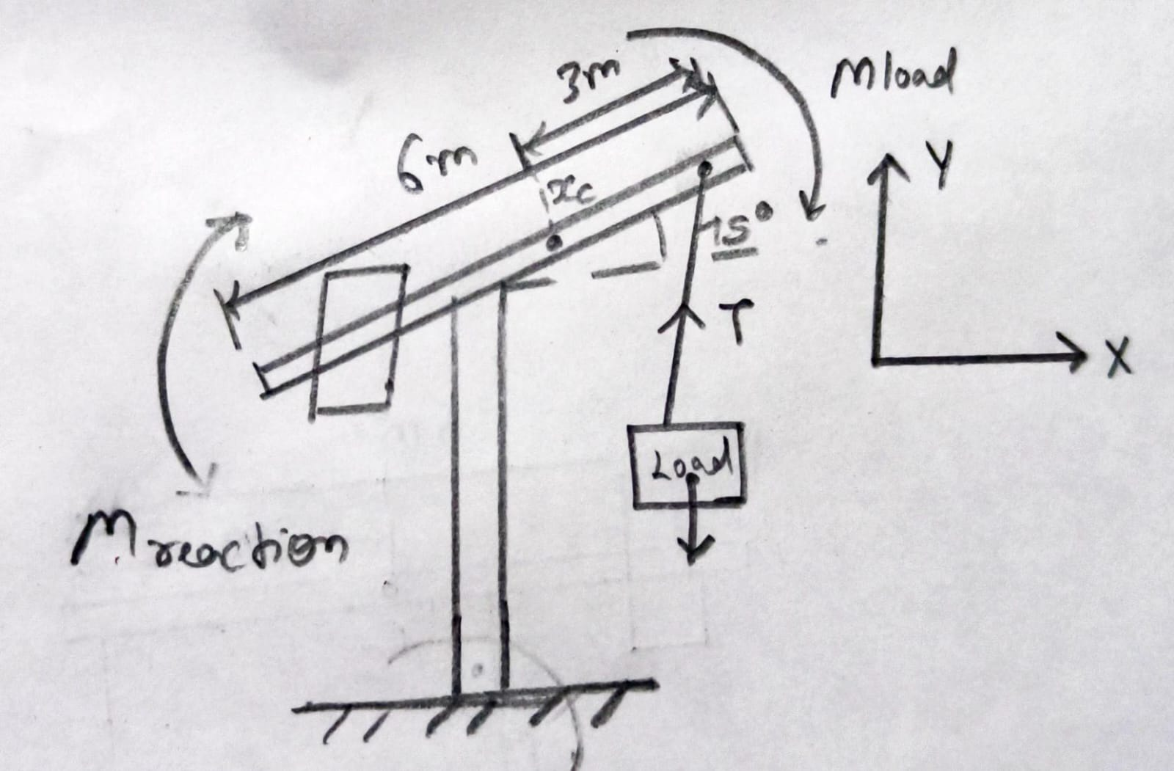

Figure 3: Free Body Diagram of the crane, showing external forces acting on the system

Figure 4: FBD of the boom, indicating tension in the supporting cable and weight of the load

Figure 5: FBD showing the forces and reactions at the base of the crane

The free body diagrams are critical for visualizing all the forces acting on the crane and its components.

## Step 1: Centroid of the Boom

The boom of the crane is modelled as a uniform beam. The centroid represents the point where the weight of the boom can be concentrated.

For a uniform boom with length L = 6m, the centroid is located at the geometric centre:

$$x_{c }= \frac{L}{2}=3m$$

The centroid helps in calculating the moments acting on the boom, as forces will generate moments of this point.

## Step 2: Reactions at the Base

The base of the crane experiences both horizontal and vertical reactions due to the load and the geometry of the crane. These reactions must be calculated to ensure that the base can resist the applied forces without tipping or collapsing.

Given:

* Weight of the load: $W=1000 \text{kg}×9.81 {\text{m}\text{/}\text{s}}^{2}=9810 \text{N}$
* Horizontal distance of the load from the base: $d=4 \text{m}$
* Angle of the boom: $θ={45}^{∘}$

The reactions at the base include a vertical reaction Ry, a horizontal reaction Rx, and a moment reaction M. These reactions can be calculated using the following equilibrium conditions:

* **Sum of Forces in the Horizontal Direction: $\sum{F_{x}}=0=T\cos\left(θ\right)-R_{x}$**
* **Sum of Forces in the Vertical Direction: $\sum{F_{y}}=0=T\sin\left(θ\right)+R_{y}-W$**
* **Sum of Moments about the Base: $\sum{M}=0=W×d-T×L×\sin\left(θ\right)$**

Where:

* T is the tension in the supporting cable.

These equations can be solved simultaneously to find the reactions at the base.

## Step 3: Tension in the Supporting Cable

The supporting cable plays a crucial role in maintaining the equilibrium of the boom by resisting the moment created by the load. To calculate the tension T in the cable, we apply the equilibrium condition for forces acting along the boom.

The tension in the cable provides both vertical and horizontal components that counteract the load and prevent the crane from tipping.

$$T=\frac{W×d}{L×\sin\left(θ\right)}$$

By substituting the given values, we calculate the tension required to keep the crane in equilibrium.

## Step 4: Moment Calculation

The moment acting on the crane due to the load is an essential factor in determining its stability. The moment is calculated as:

$$M_{\text{load}}=W×d$$

The moment generated by the tension in the supporting cable must counteract this load moment to prevent the crane from tipping over. The crane's base provides a reaction moment to ensure stability.

$$M_{\text{reaction}}=T×L×\sin\left(θ\right)$$

By ensuring that the moments are balanced, we can confirm the crane's stability.

## Step 5: Frictional Forces and Safety

In cases where the crane is mounted on wheels or tracks, frictional forces between the base and the ground become significant. The frictional force helps prevent sliding and can be calculated using the following equation:

$$F_{\text{friction}}=μN$$

Where:

* is the coefficient of friction between the base and the ground.
* N is the normal reaction force (equal to the vertical reaction at the base).

For a fixed-base crane, frictional forces are negligible. However, it is important to consider the safety factor, which is a measure of the crane’s ability to withstand loads greater than the design load. A typical safety factor for cranes is between 1.5 and 2, ensuring that the crane can safely lift loads without risk of structural failure.

# Findings:

1. **Base Reactions:** The reactions at the base include both horizontal and vertical forces, as well as a moment that counteracts the moment caused by the load.
2. **Tension in the Cable:** The supporting cable must have sufficient tension to balance the forces acting on the boom.
3. **Moment Calculation:** The moments acting on the crane are calculated to ensure that the crane does not tip over.
4. **Centroid:** The position of the centroid affects the force distribution and moments acting on the boom.
5. **Frictional Forces:** In mobile cranes, friction plays a role in maintaining stability, while fixed-base cranes rely on the reaction moment.

# Conclusion:

The force analysis of a crane lifting a load provides insights into how the crane maintains equilibrium during lifting operations. By calculating the reactions at the base, the tension in the supporting cable, and the moments acting on the structure, we ensure that the crane operates safely and effectively. The centroid of the boom plays an important role in the force distribution, and considering frictional forces and safety factors further enhances the crane’s reliability in real-world scenarios.

References

1. Hibbeler, R.C., "Engineering Mechanics: Statics," 14th Edition, Pearson Education.
2. Beer, F.P., Johnston, E.R., and Mazurek, D.F., "Vector Mechanics for Engineers: Statics," 11th Edition, McGraw-Hill.
3. Gere, J.M., and Timoshenko, S.P., "Mechanics of Materials," 7th Edition, Cengage Learning.